F.16 -

Functionality
This program is used to carry forward the balances of the general ledger to the new fiscal year. You can run this transaction multiple times. You should always run it if there are discrepancies between the balances of the GL accounts in the previous and the current fiscal years.

The GL balances are carried forward as follows:
- Balance sheet accounts are transferred with all additional account assignments to the same account numbers.
- P&L accounts are carried forward to the retained earnings account. Additional account assignments are not transferred. The transaction currencies are not transferred and are totaled in the local currency.

Scenario

You want to generate a report because there are discrepancies between the balances of the GL accounts in the previous and the current fiscal years.

Requirements
None.

Menu Path | Accounting → Financial Accounting → General Ledger → Periodic Processing → Closing → Carrying Forward → F.16 - Balance Carry Forward
Transaction Code | F.16

1. Double click on F.16 - Balance Carry Forward.

Balance carryforward

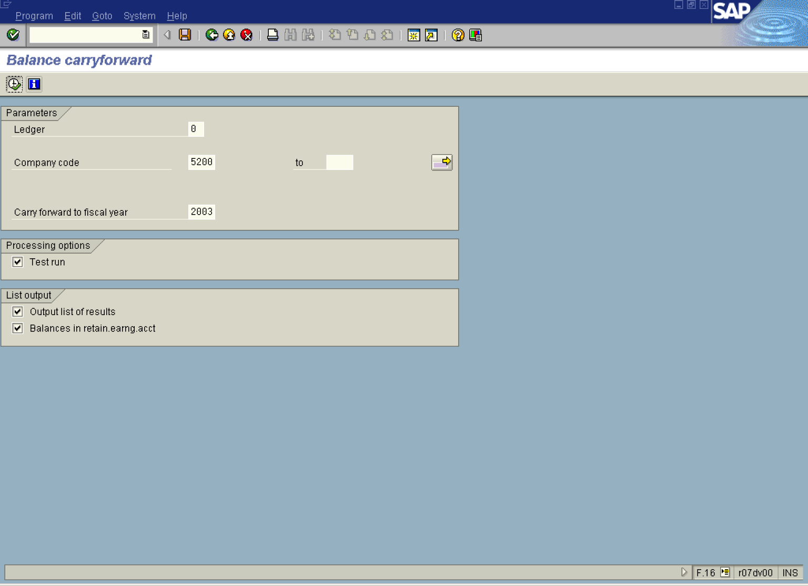

2. Update the following fields:

Field Name | Field Description | Values
Ledger | Standard GL ledger = 00. Since we use parallel currency 1 and parallel currency 2, we also have ledger P1 & P2 | 00, P1, P2
Company code | Code identifying a separate legal entity for which a separate set of accounts is maintained for external reporting purposes | Example: 5200
Carry forward to fiscal year | Enter here the fiscal year number you want to carry the balances to. | Example: 2003

3. If you want to display the individual balances of the P&L statement accounts which are carried forward to this retained earnings account, click <checkbox> Balances in retain.earng.acct .

Tip: This process, as many processes in SAP, can be run in test or production mode.

4. Click Enter Button to confirm your entries.

5. Click Execute button to carry forward balances and display a report:

Balance carry forward Ledger 00 for the year 2003 Test run

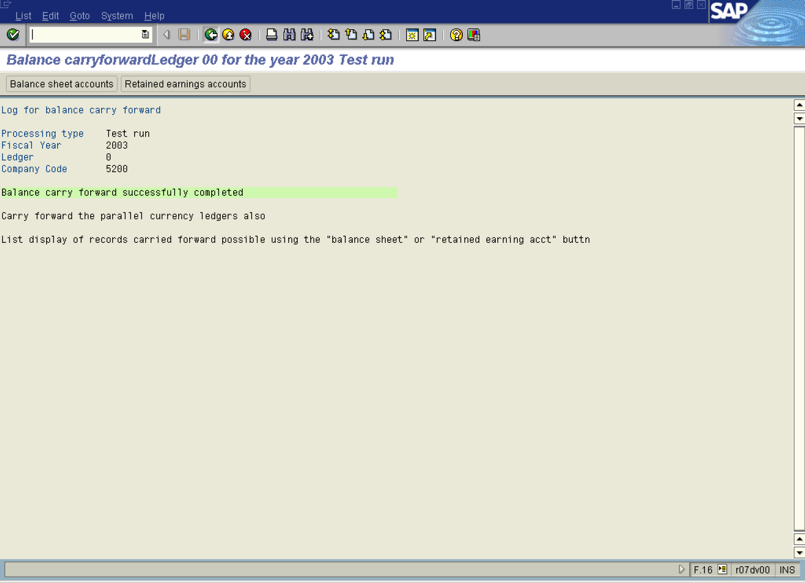

6. You can display individual balances of the particular accounts. Click to display balances of balance sheet accounts:

Display of balance sheet accounts

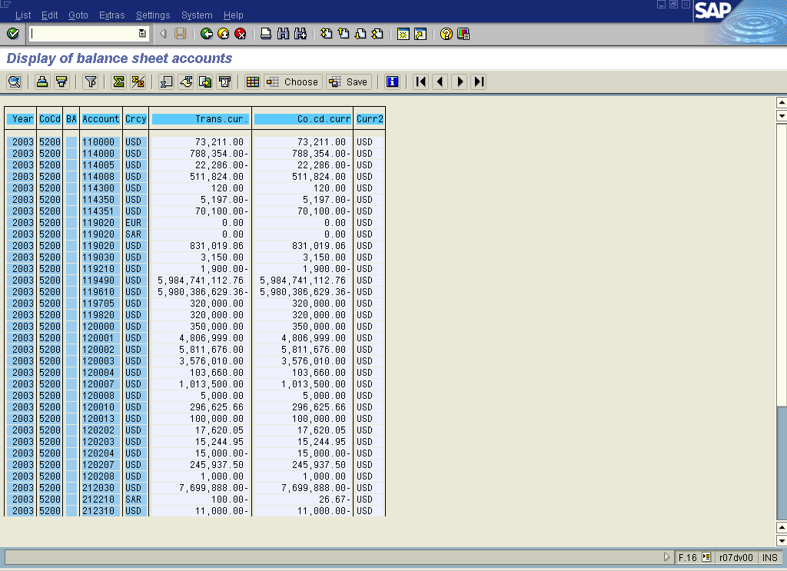

Tip: You can print this report or exported to MS Excel.

7. Click Back Button .

8. Click button to display balances of P&L accounts:

Display of retained earnings accounts

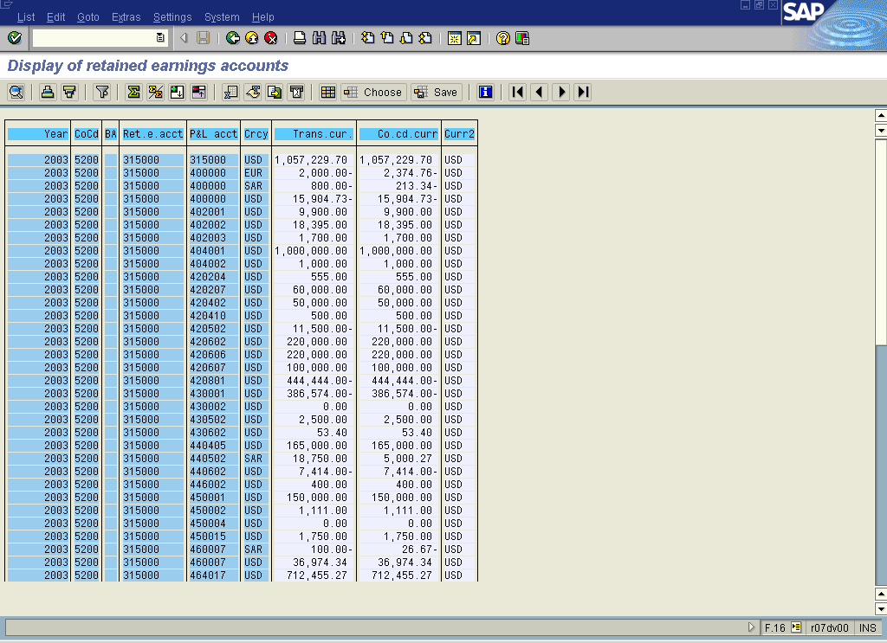

9. Click Back Button .

Balance carryforward

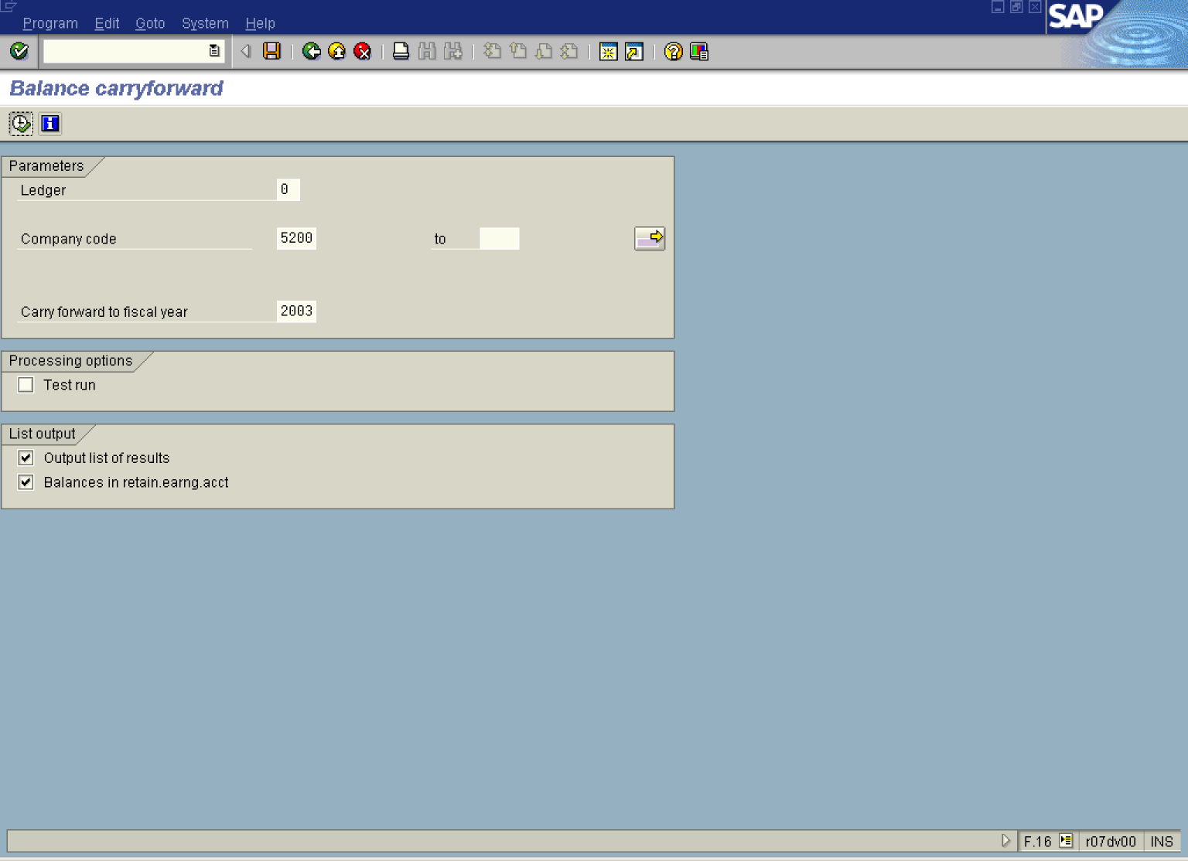

10. The message bar displays “Balance carryforward to fiscal year 2003 successful”

